C29PE Tutorial 4 Questions with Solutions – Market Structures

- To which of the above four categories do the following apply to the member firms? (There can be more than one market category in each case.)
  - Firms face a downward sloping demand curve.
Monopoly, oligopoly, monopolistic competition
  - New firms can freely enter the industry
Perfect competition, monopolistic competition
  - Firms produce a homogeneous product
Perfect competition, some oligopolies

  - Firms are price takers
Perfect competition
  - Firms face an elastic demand (but less than infinity) at the profit-maximising output.
Monopoly, oligopoly, monopolistic competition

  - Firms will produce where MR = MC if they wish to maximise profits.
All
  - There is perfect knowledge on the part of consumers of price and product quality.
Perfect competition
- 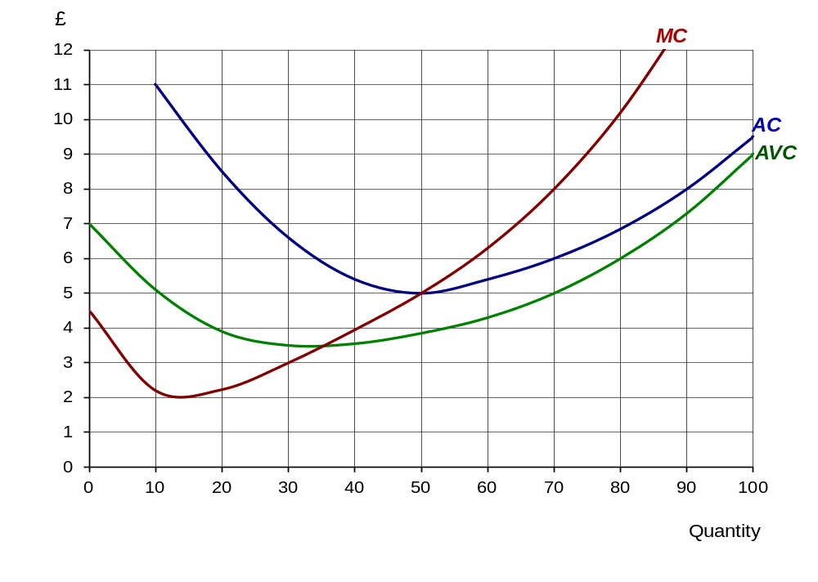The following diagram shows the cost curves of a firm under perfect competition.

  - How much will the firm produce to maximise profits at a price of £8 per unit?
70 units
  - What will be its average cost of production at this output? £6
  - How much (supernormal) profit will it make? £2 × 70 = £140
  - How much will the firm produce to maximise profits at a price of £5 per unit?
50 units
  - How much (supernormal) profit will it make? 0
  - How much will the firm produce to maximise profits at a price of £4 per unit?
40 units
  - What will be its profit position now? A loss of £1.50 × 40 = £60
  - Below what price would the firm shut down in the short run? £3.50 (where P = AVC)
  - Below what price would the firm shut down in the long run? £5 (where P = AC)

- A monopolist is faced with the following cost and revenue curves:
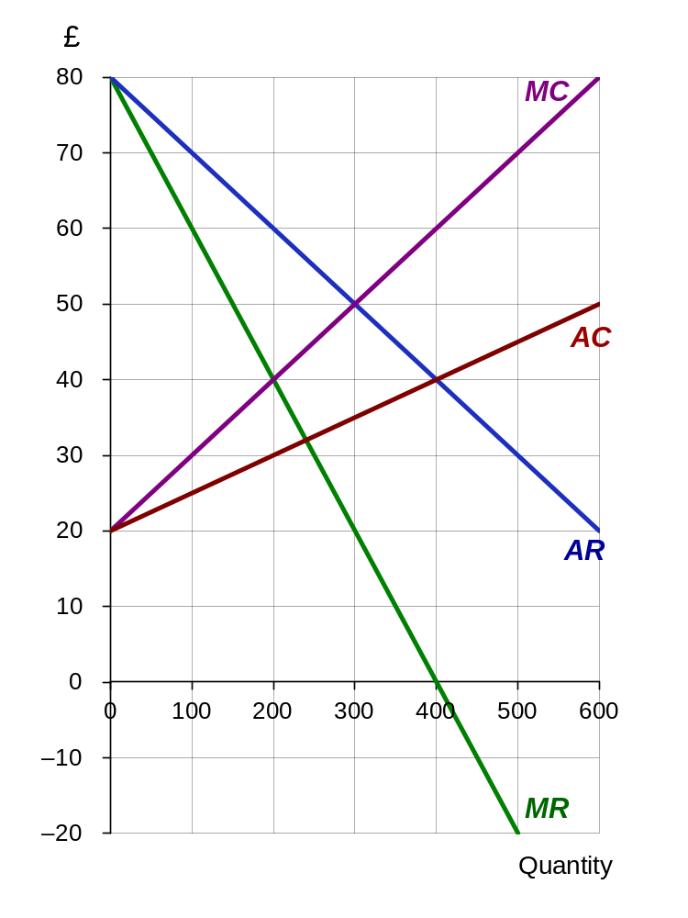
  - What is the maximum-profit output?
200 units (where MC = MR)
  - What is the maximum-profit price?
£60 (given by AR curve at 200 units)
  - What is the total revenue at this price and output?
£12,000 (i.e. £60 × 200)
  - What is the total cost at this price and output?
£6000 (i.e. £30 (AC) × 200)
  - What is the level of profit at this price and output?
£6000 (i.e. TR – TC)
  - If the monopolist were ordered to produce 300 units, what would happen to the market price?
It would fall to £50 (given by AR curve)
  - Why might a regulator order the firm to increase output to this level?
So that the firm’s marginal cost would be equal to the market price, maximising the social value of its activities.
  - How much profit would the firm make?
With price £50 and average cost £35, it makes £15 per unit sold so total profit is 15 * 300 = £4500.
  - Assume now that the monopolist decides not to maximise profits, but instead sets a price of £40. How much will now be sold?
400 units (given by AR curve)
  - What is the marginal revenue at this output? 0
  - What does the answer to (l) indicate about total revenue at a price of £40?
With zero marginal revenue, the firm has set its revenue maximising output.
  - What is the price elasticity of demand at a price of £40? (You do not need to do a calculation to work this out: think about the relationship between MR and TR.)
When the firm maximises its total revenue, you should recall that as well as having zero marginal revenue, it has unit price elasticity of demand, so that the PED = -1.
Sample exam questions
4. Applying the structure-conduct-performance approach, what might we conclude about the likely structure of an industry, such as motor vehicle manufacturing in which there are substantial economies of scale?
With cost per car lower for large firms than for small firms, we expect that small producers are likely to exit the market, perhaps by merger or takeover. We expect the industry to be dominated by a small number of very large firms (students might give examples, such as GM in the USA, Volkswagen in Germany, or Toyota in Japan, suggesting that the motor vehicle industry is substantially integrated globally).
Students should then discuss the implications of there being only a small number of large companies. This can be a general discussion, touching on competition on perceived quality and non-price competition, very high levels of marketing activity, and the possibility of collusion

5. There is some debate as to whether Google is considered to hold a monopoly in the market for internet search engines. Describe the changes Google would face if it lost any monopoly power it held, due to two strong competitors entering the market.

If Google has a monopoly, we would expect it to exhibit the following characteristics: it would be the only firm in the industry (or a sizeable proportion of it); there would be a lack of close substitutes; entry to the market would be restricted or completely blocked; its product would be unique; it would be able to benefit from substantial economies of scale; and it would have considerable control over price.

If the two new firms entered the market, the market structure would change into an oligopoly. Entry would remain restricted but the firm would have less control over price. The demand curve would still be downward sloping and inelastic, but less so than under monopoly. Google would now have to consider the reactions of its rivals if it wanted to change its pricing structure.

Interdependence is now important. Each firm will need to take account of the behaviour of the others when making its own decisions. Each firm is affected by its rivals’ actions. If a firm changes the price of specification of its product, the sales of its rival will be affected.

Google and its rivals will be pulled in two directions to compete or to collude.

Collusion can reduce uncertainty. A formal collusive agreement is called a cartel – in a cartel the three firms would maximise profits by working together and acting like a monopolist. Another option available to them would be tacit collusion, such as dominant firm price leadership.

Even if firms do not collude, they will still need to take account of rivals’ likely behaviour when deciding their own strategy. Firms will make assumptions about how they believe their rivals will behave (normally based on past behaviour).

Supplementary questions (will not be discussed in class)
6. In which of the four categories would you place each of the following? (It is possible in some cases that part of the industry could be in one category and part in another: if so name both.)
  - A village post office Monopoly for certain people and products
  - Restaurants in a large town Monopolistic competition
  - Banks Oligopoly
  - Games console manufacturers Oligopoly
  - Producers of barley Perfect competition (or close to it)
  - Water supply Monopoly
  - Local buses Monopoly or oligopoly
  - The market for foreign currency Perfect competition (or close to it)

7. What is wrong with the following claim? A monopolist can choose how much to sell and at what price.
A monopolist can choose either price or quantity but not both. Given its demand curve, there is only one price corresponding to each level of sales and only one level of sales corresponding to each price.

